**Valve Team Tests and Results**

The valve team found in the testing phase that 10N was not enough to fully close the tubing. The team was using the observed value found using the above suction procedure, which did not account for pressure buildup from the CO2 canister. As such, the team had to pivot to the mechanical advantage design as seen outlined in the spring semester section. Early tests of this prototype determined that, though the carbon filament could withstand the force, the tubing holder was flexing. Therefore, a temporary support structure was designed as shown in the figure below.

Using this design, as seen in Figure 19, the valve could fully pinch the 20cm 1/16" ID Silicone tubing and prevent all CO2 from continuing into the Pioreactor vial. The figure below verifies that, when the valve is powered off, there is no CO2 continuing into the valve and, when the solenoid is powered with 12V, the valve opens. The valve pulls a maximum of 2.36 Amps when powered by 11.31V which is within the constraints of the design.

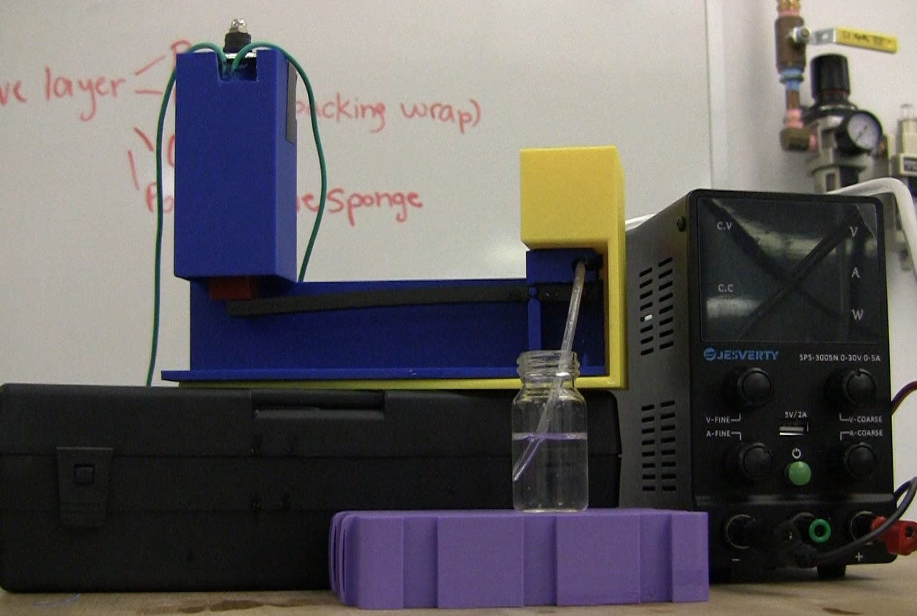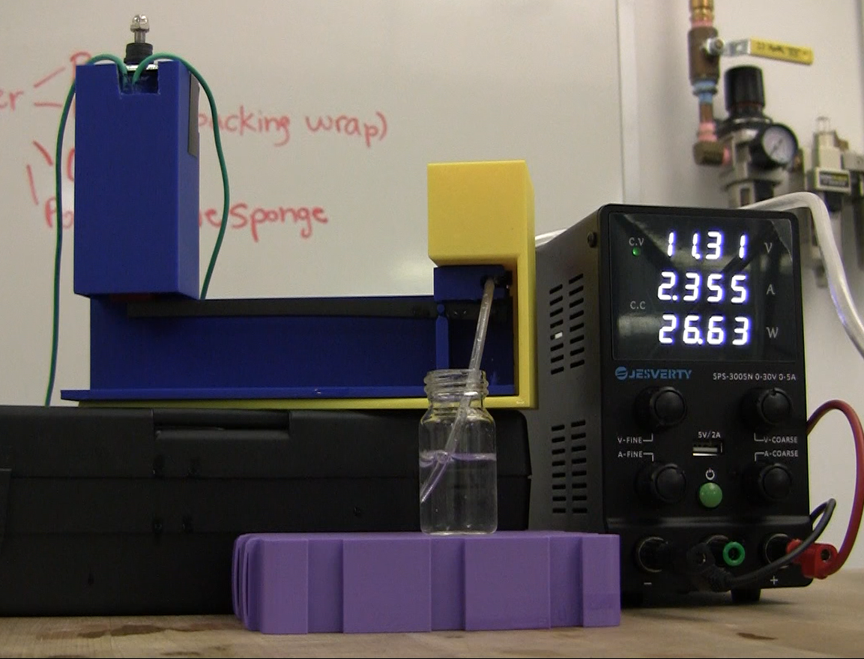

*(Left) Solenoid pinch valve in the NC position (Right) Solenoid pinch valve powered and fully open*

This visual inspection allowed the team to determine that the design met the deliverable.

**Valve Team Future Recommendations**

The solenoid valve is functional, but has some design flaws that can be addressed in future work. The first of which is the lever occasionally slipping out of alignment, preventing the solenoid hat from coming into contact with it and making the valve non-functional. This can be corrected either by adding vertical alignment supports, or by making the solenoid hat and lever one continuous piece. Additionally, the valve is large and, now that the proof of concept prototype has been verified, if the same ratio is kept it is possible to shorten the lever and therefore the entire footprint of the valve system. Material selection would have to be made with careful consideration as decreasing the size of the lever increases the stress in the material, making it more susceptible to fatigue stress. Finally, the design of the valve could be changed to allow for more seamless integration into the system. Currently, the pinching area is very large (0.5 in) and could be shrunk to better accommodate the short 20cm 1/16" ID Silicone tubing. Additionally, the supports can be integrated into the design and the tubing holder can be made thicker to stay rigid under the high applied force. A mock-up of this integrated support design can be seen in the figure below.

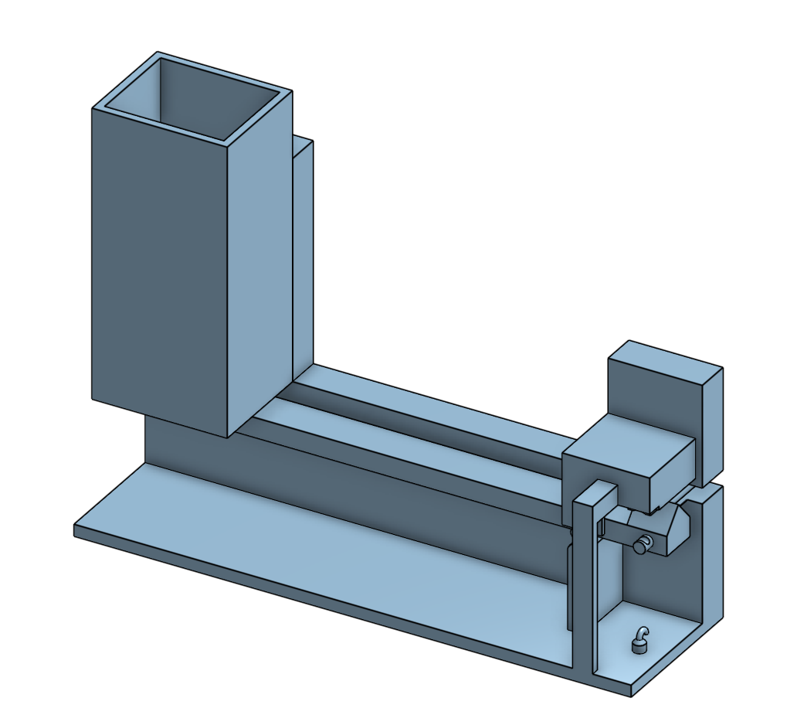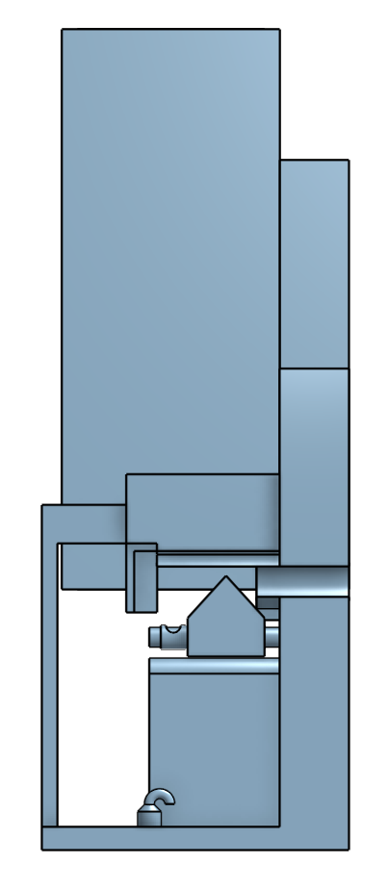

*Figure 20: Solenoid Pinch Valve with Lever and Integrated Supports*